Case 10-AM,S-Peru-Stirrup Bottle-Tumi Design-400-600 CE

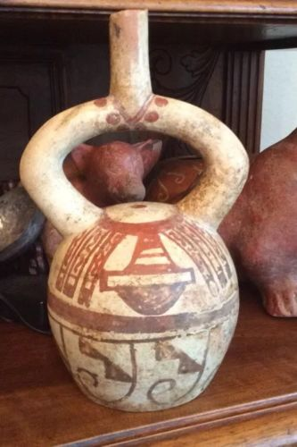

[**Moche IV Blow Bottle 400-600AD Weapon Bundle And Wave + Step Motif**](http://www.ebay.com/itm/221952944734)